PHASE 7 : Inserting New Data In Excel Format

Steps :
- Navigate to All menus.

- Search for Load data Under System Import set Open Load Data.

- Fill the details as

- Import set table as select Existing table {Employee Import}.

- Source of Import is Select File and choose the file from Files.

- Sheet number : 1, Header row : 1.

- Now Click submit.

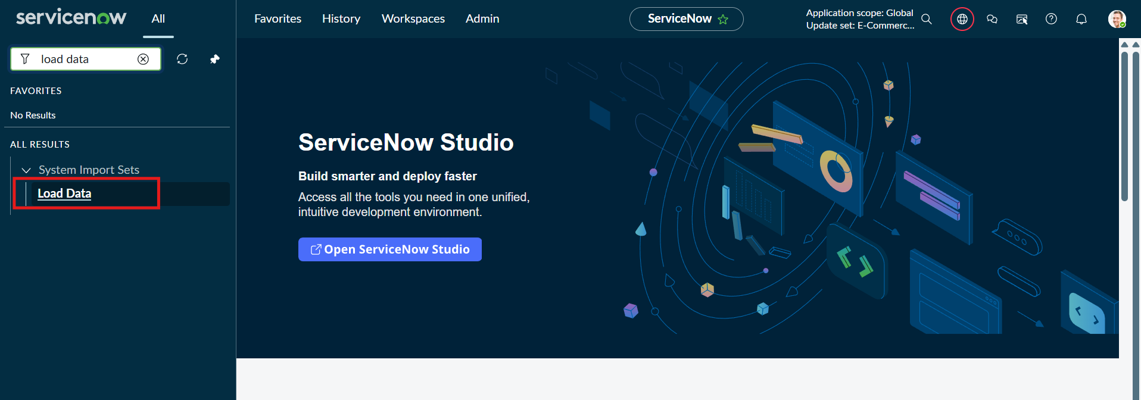
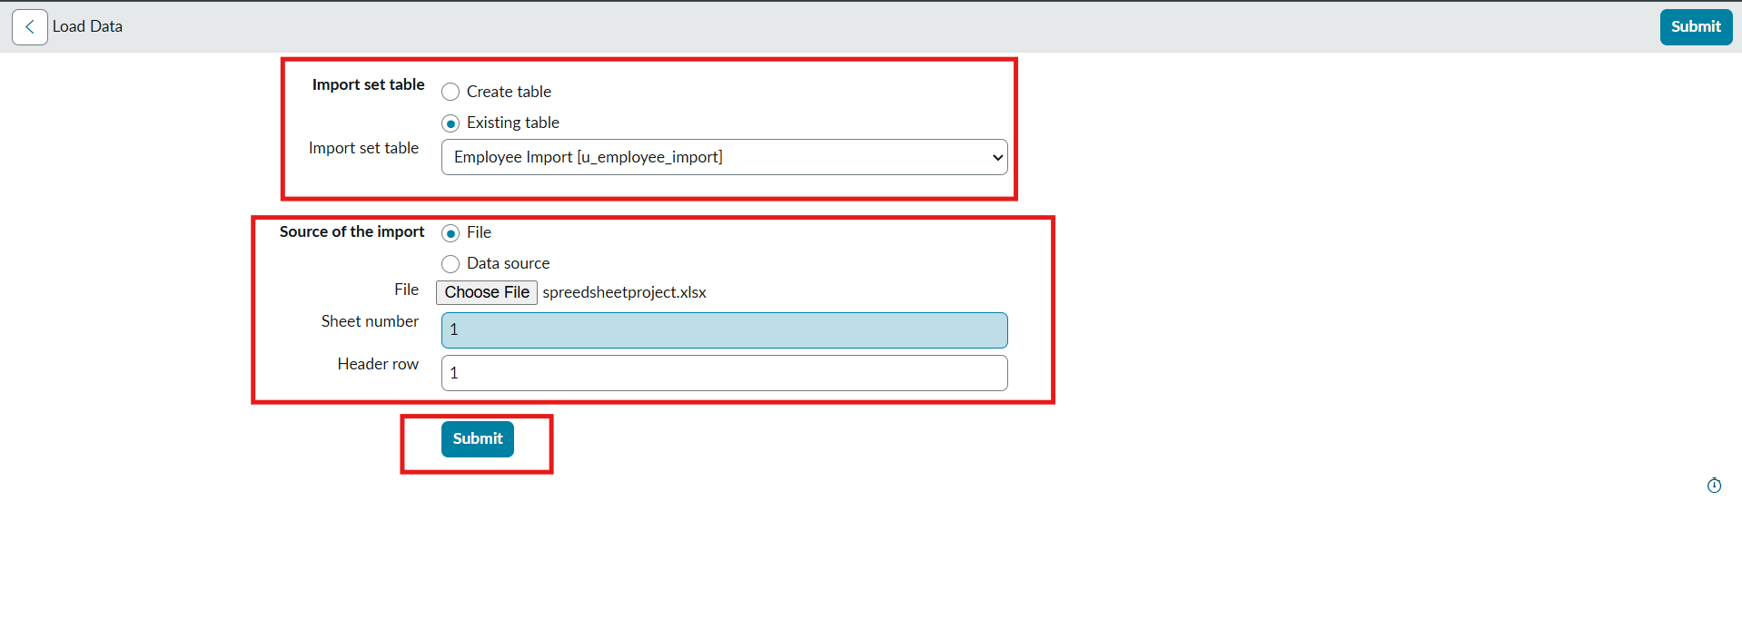

- Newly Created Excel Data is this.
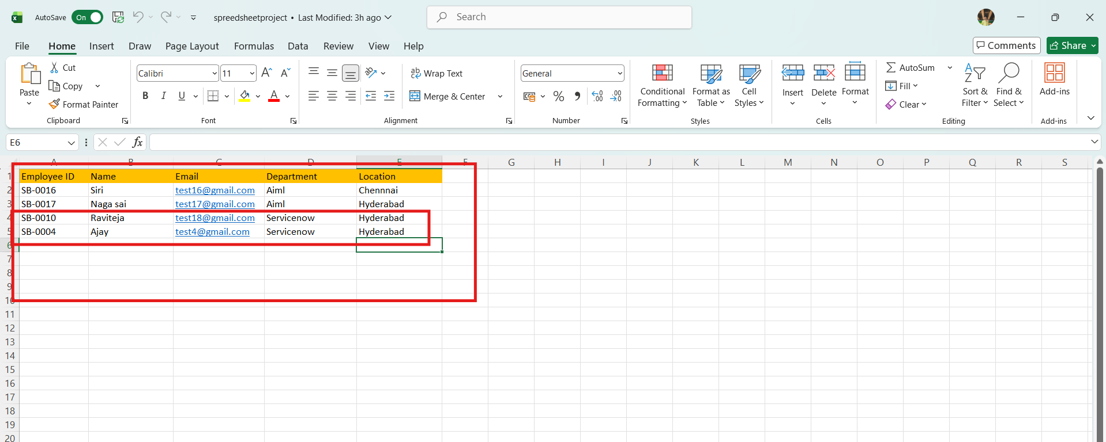
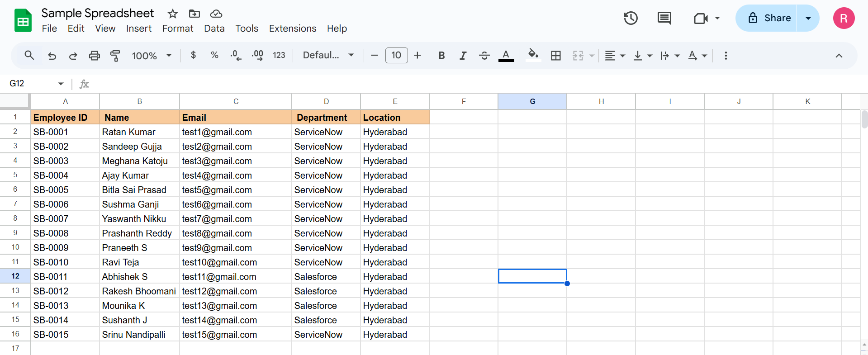
- It is the previously added data.

- Now, In this new data we added 4 rows of the 2 rows with the same existing data with different Name changed and Email changed.

- That Raviteja Employee Email was Changed to
[test10@gmail.com → test18@gmail.com ].

- And Employee ID with SB-OOO4 name was changed to
[Ajay kumar → Ajay].

- And two other new Employee ID’s are added.

- Now after submitting the form it appears as State Completed and Success.

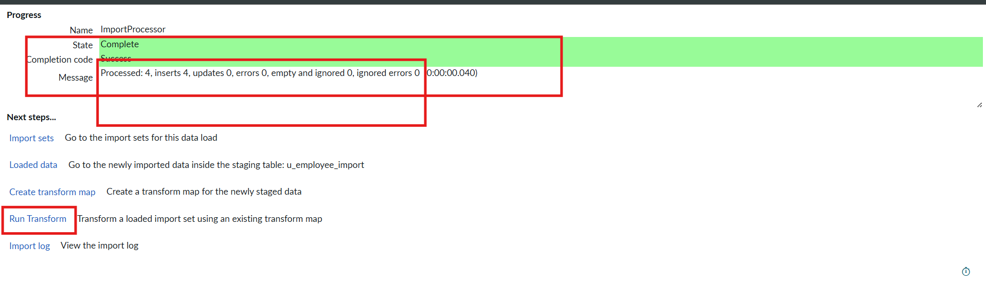

- Now Click the Run transform Under the next steps.

- Then it opens Specify Import set and transform map which is previously selected transform map then Click Transform button.

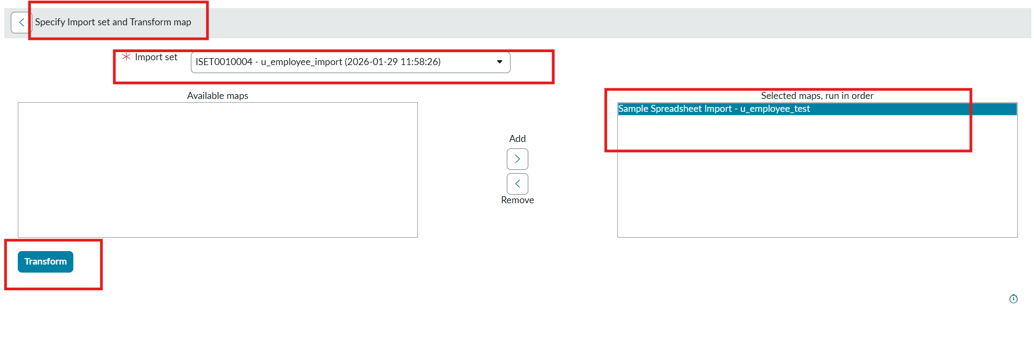
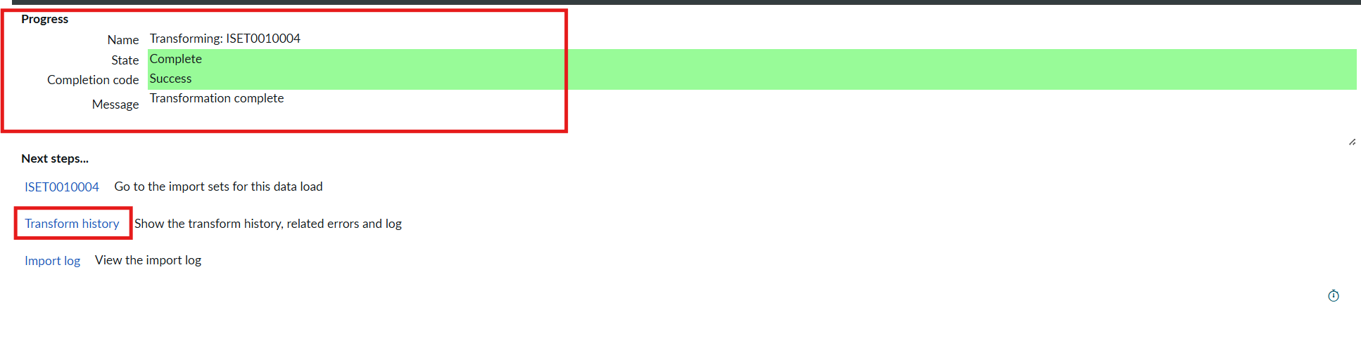
- Now the State is completed and Success.

- Now again click on the Transform history then it shows the newly added data and its status of Inserted and Skipped values out the given data.
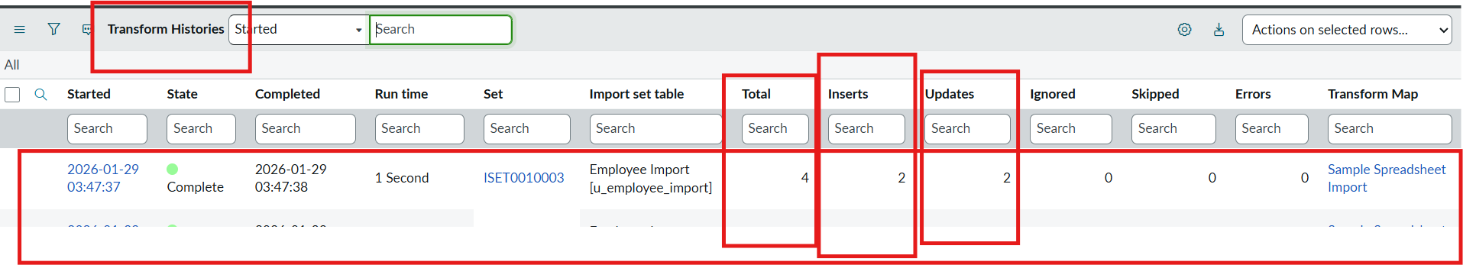
- From the above figure : total 4 rows are uploaded out of 2 are Inserted that are two new ID’s.

- And 2 rows are updates that are Same ID’s with different Name and different Email that we changed.

- Then Open the Employee Tests table and see the rows updated and inserted.
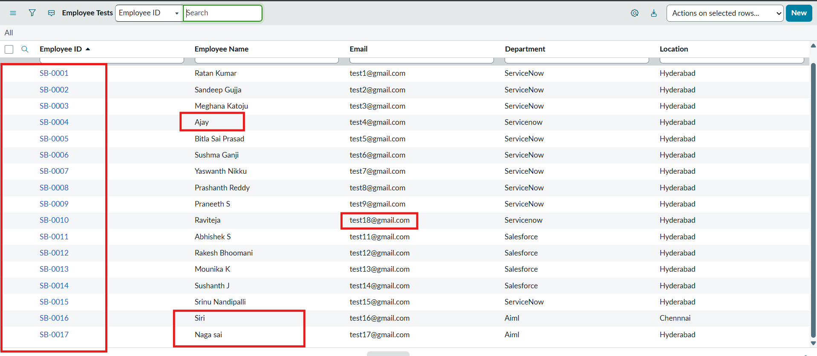

- Now Repeat the Phase 7 with the same steps and same Excel sheet and Submit to check how many rows are updated and Inserted with the same data.

- Then Open the Transform history to check.
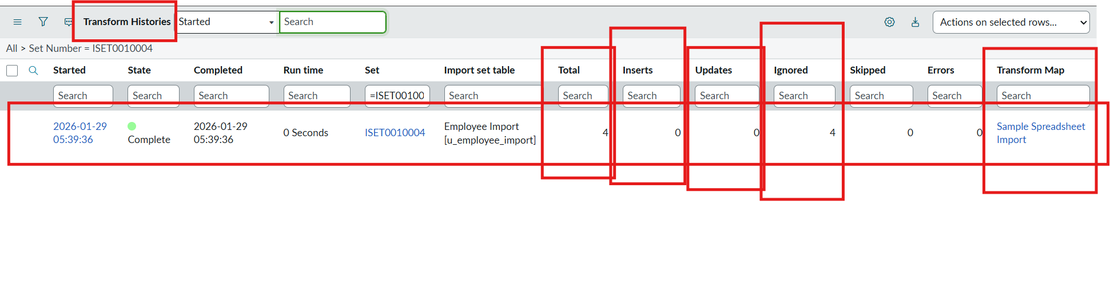
- Here we can see the total 4 are uploaded.

- On that 0 rows are Inserted and updates 0 and Ignored 4 rows.

- That same sheet we uploaded to the same transform map we created.

